Mise en Place for Measuring + Weighing Meat

Mise en Place ; is practicing orderliness. To be successful cooks you need to develop the habit of getting everything ready
before you actually begin cooking. It is Pre-preparation for the task you are assigned to do.

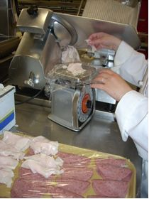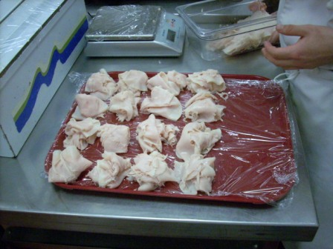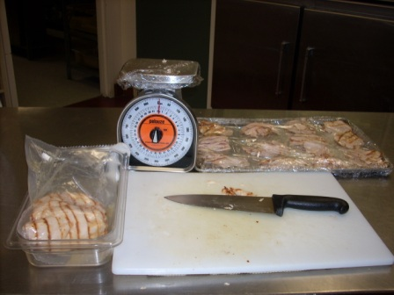
Note! Cooked chicken in insert
while preparing Not on counter.

Assemble the following Equipment:

- Scale, Saran wrap or insert for scale to weigh food
- Cutting board, stabilizing cloth, chef knife, and plastic trays for portioned meat/ cheese.
- Bus pan or insert to place meat in – no raw or cooked meat on counter Please!

