Mise en Place for Wrapping + Labeling

Mise en Place ; is practicing orderliness. To be successful cooks you need to develop the habit
of getting everything ready before you actually begin cooking. It is Pre-preparation for the task you are assigned to do.

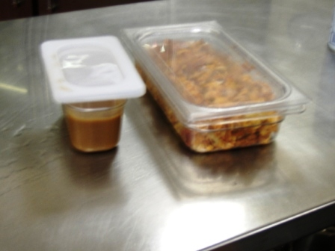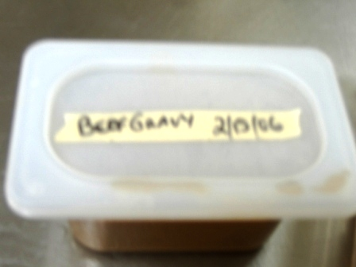
Assemble the following Equipment:

- Masking Tape, Felt pen, Lid or Saran wrap
- BEFORE putting in fridge. Down Size the food into a small container
- NOTICE ! IS there a container of pepper tops already in the fridge?
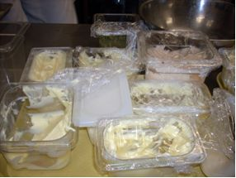
Please just ADD to it.
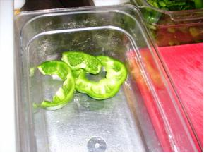 Do NOT use another container. -----}

